FOR IMMEDIATE RELEASE: Jan. 18, 2010 CONTACT:
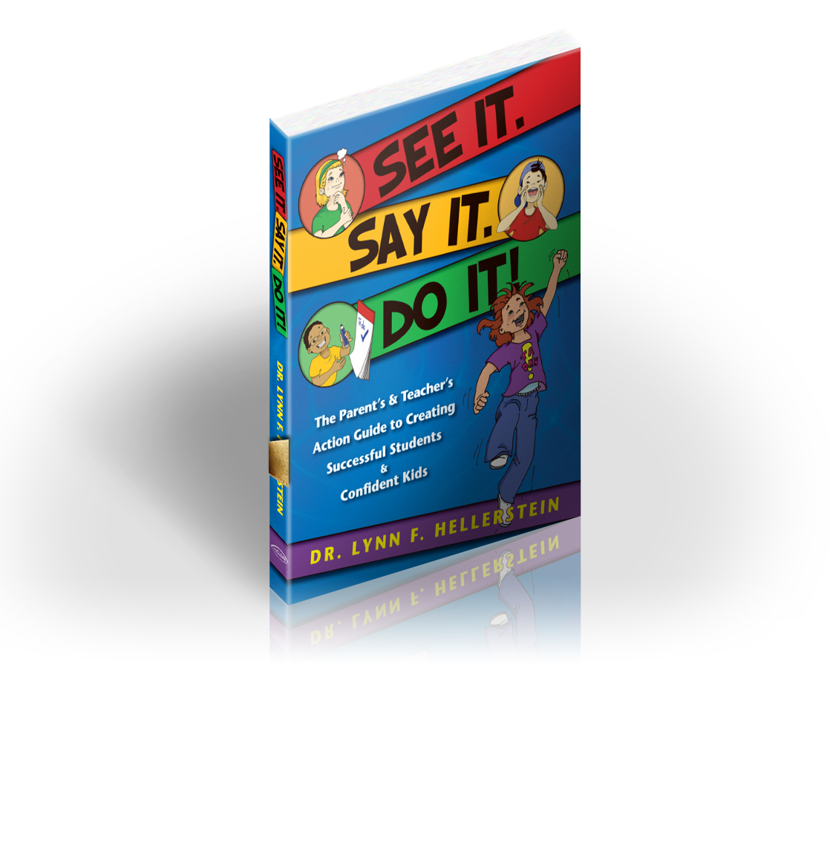
Meghan Hayes
303-850-9499
Meghan@LynnHellerstein.com

www.LynnHellerstein.com

Can Your Child See…Really See?
Optometrist and vision therapy pioneer Dr. Lynn Hellerstein puts the focus on vision, not eyesight, in breakthrough book

CENTENNIAL, Colo. – Grace hit the wall in third grade. Janet watched her bright little learner disappear as anger, frustration and boredom replaced her daughter’s curiosity. Something was wrong. Teachers told Janet she had unrealistic expectations; she pushed her daughter too hard. She should accept Grace’s limitations. “Janet,” they said, “Back off.”

Janet didn’t give up. A thorough vision exam revealed that while Grace had perfect 20/20 eyesight, she could not see.

A few months of vision therapy corrected her vision problems, and gave her strategies for success in school. Now, Grace is a confident child who thrives in a gifted program for language arts and math.

"Many children have 20/20 eyesight, yet still have vision problems. They can read an eye chart just fine. But they can’t read a book,” says Dr. Lynn F. Hellerstein, optometrist and author of See It. Say It. Do It! “More than 15 visual skills are required for learning and reading. Vision is the dominant learning sense and greatly impacts a child’s ability to read, learn and succeed in school. One in four children has vision problems.”

What about children with normal vision who find reading, writing, spelling and math frustrating? Or, children labeled as “behavior problems,” or stressed, anxious task avoiders? During her 30 years of clinical practice, Dr. Hellerstein developed a visualization protocol that can replace struggle with success and open children’s eyes to a world of possibilities.

“Visualization isn’t New Age,” Dr. Hellerstein says. “It’s an age-old practice successful people use to enhance performance—in academics, sports, music and with life goals.” Mastering visualization skills transforms children and creates success in school and life. Timid children learn to take risks and enjoy adventure. Disinterested children find joy in reading and frustrated children experience the satisfaction of solving a math problem or hitting a baseball.

Who can benefit from Dr. Hellerstein’s plan? Anyone who can answer “yes” to any of these questions:

• Does your child struggle in school?
• Does your child resist reading or writing?
• Does your child have difficulty with or avoid sports?
• Does your child have test anxiety?
• Does your child seem smart in everything but school?
• Does your child lack confidence?

With Dr. Hellerstein’s pioneering book, See It. Say It. Do It!, parents and teachers now have solutions to many of the blocks that affect a child’s ability to learn and perform.

See It. Say It. Do It! is an easy to read, delightfully illustrated book that shows parents, educators and therapists how visualization improves children’s lives. It provides easy, practical, step-by-step strategies and activities to enhance children’s visualization skills by teaching them how to create pictures in their minds, declare their goals and take action to make their dreams reality.
###

Optometrist Dr. Lynn F. Hellerstein, O.D., FCOVD, FAAO, has been a pioneer in vision therapy for more than 30 years. Her expertise and leadership in developmental optometry has inspired thousands to improve their vision and enhance their lives. She has successfully treated children and adults with learning, visual perception and visual motor difficulties.

Dr. Hellerstein is the founder of a private optometric practice in Centennial, CO (in Metro- Denver). She is a frequent lecturer and consultant to educational groups, sports teams, rehabilitation and other medical professionals.

A Fellow of the College of Optometrists in Vision Development (COVD) and American Academy of Optometry, Dr. Hellerstein is a past president of COVD. She is an adjunct professor at several colleges of optometry throughout the United States.

Dr. Hellerstein lives in Colorado, and is available for interviews and speaking engagements.
###
Publication Data:
See It. Say It. Do It!
ISBN 978-0-9841779-0-5
Price: $25
HiClear Publishing, LLC ~ 7 x 9, Trade Paper with Flaps ~ January 2010
264 pages including: More than 50 illustrations and tables, 28 activities, 33 Dr. H’s Insights (tips), and 20 endorsements

Contact Information:
Meghan Hayes 303-850-9499 Meghan@SeeItSayItDoIt.com
Dr. Lynn Hellerstein 303-850-9499 DrH@SeeItSayItDoIt.com
www.acha.org 3

