Vision Processing Games List

Here is a list of some educational toys and activities for kids of various ages and abilities. These toys help develop visual processing and visual motor skills! Use these suggestions at your discretion. These games do not replace appropriate vision care and treatment.

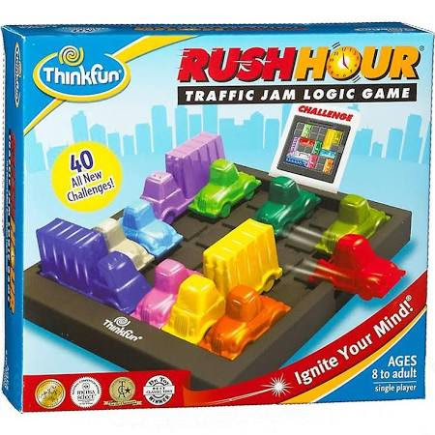
Rush Hour
Ages 8 and up; Traffic Jam/Logic game. Rush Hour is a challenging game of strategy and visual thinking. There are four levels of difficulty so kids and adults alike can enjoy this puzzle. This game is available in many formats: large cards, mini version, digital. Voted one of Parents' Choice Best 25 Toys of 25 Years!

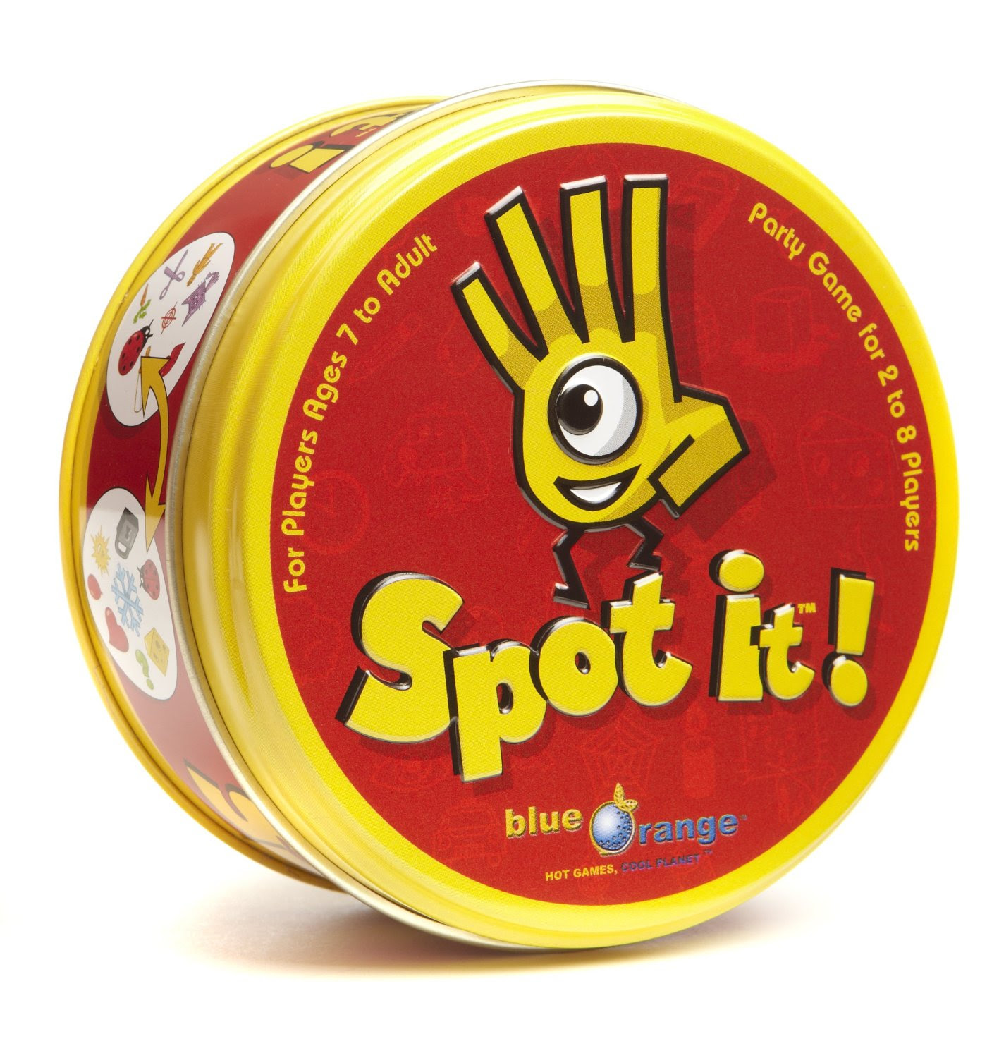
Spot It
Ages 7 and up; Spot It is a fast paced matching and visual perceptual game. This game develops focus, visual perception skills, speech-language skills, and fine motor skills. An award-winning game of visual perception for the whole family.

Blokus
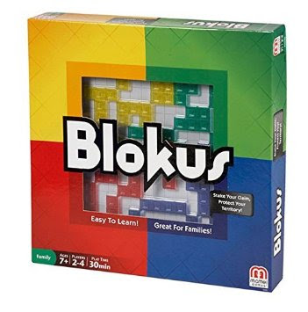
Ages 5 and up; Blokus is a strategy games that encourages creative thinking and spatial planning. As players take turns placing their 21 pieces on the board, each piece played must touch another piece of the same color, but only at the corners.

Set Game
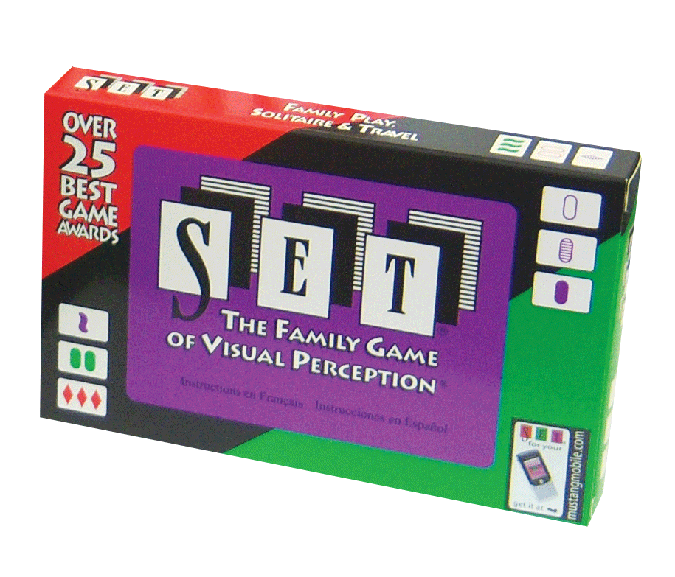
Ages 6 and up; Set Game is a fun and challenging visual discrimination game. You must find a set using the unique cards with four different attributes; number, symbol, shading, and color. Winner of over 35 Best Game awards.

Blink
Ages 3 and up

Farkle
Ages 6 and up

Eye-Hand Coordination and Spatial Skills
(thanks, Dr. Jen Simonson, for your inspiring ideas)
- Jenga
- Perfection
- Beading Crafts
- Jacks
- Legos
- Lacing Cards
- Weaving Loom
- Uno Stacko
- Etch a Sketch
- Light Bright
- Barrel of Monkeys
- Yo-Yo
- Squiggle Pen
- Pick-up Sticks
- Paint by Number
- Operation
- Frisbee
- Tinker Toys

Perceptual/Visual Thinking Games:
- Sequence
- Connect Four
- Parquetry Blocks
- I Spy Book
- Rubik’s Cube
- Mastermind
- Imagine That
- Tri-ominos
- Racko
- Simon
- Dominoes
- Pentominoes
- Where’s Waldo
- Block by Block
- Battle Ship
- Tanagrams
- Jigsaw Puzzles
- Memory
Hellerstein & Brenner Vision Center, PC and its staff have no personal connection or financial interest in the above games. Use these suggestions at your discretion. These apps do not replace appropriate vision evaluation or vision therapy treatment. If you are experiencing problems with your vision or vision-related activities, please schedule a comprehensive vision examination with a Developmental Optometrist.

